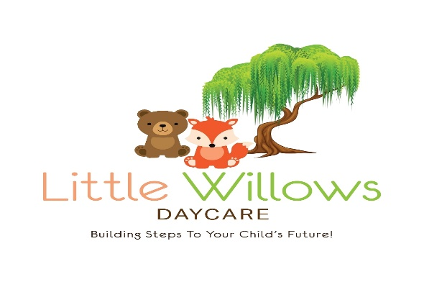
Little Willows Daycare
Building Steps To Your Child’s Future
Grandview, MO 64030
816-729-6238
www.littlewillowsdaycare.com

Thank you so much for requesting more information about Little Willows Daycare. We are thrilled that you are looking for the absolute BEST early education opportunity for your family! We have included some information about our many programs and services here at Little Willows Daycare. You can also find lots of information on our website. Please don’t hesitate to give us a call if you have any questions. Also, if we haven't already scheduled a tour, give us a call ASAP so we can set up an appointment for you to come see our facility! We know you’re going to love it!

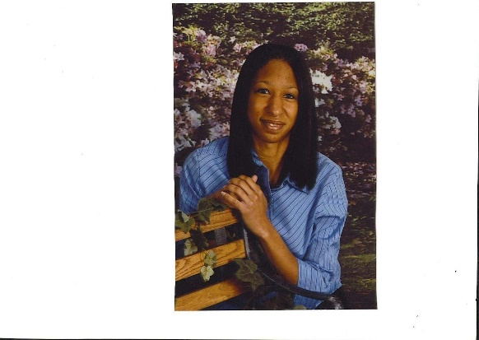
We look forward to meeting you and your family,

Your Center Management Team

Owner and Center Director


Infant Program
Our infant program is completely de-voted to the well-being of our infants. We provide our littlest munchkins with a quiet, serene atmosphere where they can play and learn and just be babies! We have separate play and nap rooms, allowing for a more relaxed, peaceful rest period. Our infants get to run the show in their classroom, eating and sleeping on demand. Our quality staff develop relationships with your baby, fostering optimal learning. They will play with colors, numbers, and shapes, sing songs, and look at books. All this along with the typical holding, cuddling, and cooing that take place all day long. Our infant program is top-notch!


Young Toddler Program
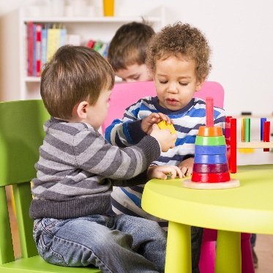
Toddlers are naturally curious and eager little learners. Their brains are like sponges, absorbing all the knowledge they can, and that is why each day in our toddler program is filled with learning activities disguised as FUN! Our learning experiences are designed to promote a toddler’s blossoming independence, develop their social skills and foster self--confidence. Our teachers are knowledgeable about the ever-changing development of toddlers and can easily adapt programs and activities to each individual child’s age and stage. You will love our program and will be amazed at just how much your toddler will learn in our super FUN Toddler Class!!

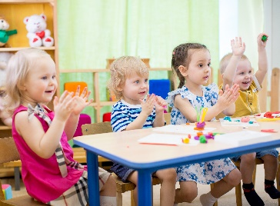
Older Toddler Program
Our 2- and 3-year-olds are so ready to learn how to be “big-kids” (ie—preschoolers.) The days in this classroom are more structured than in the toddler class, prepping them for the Preschool classes. They have daily circle time, arts & crafts, stories, songs, dancing, gym time, and lots and lots of POTTY TRAINING!!! Yes, that’s right…. learning to use the potty is an important life skill essential to developing independence, and our teachers are PRO’s at partnering with you on this. Teachers are also working with your child on small motor skills such as holding crayons/pencils and cutting with scissors as well as the basic ABC’s and 123’s of any preschool class!
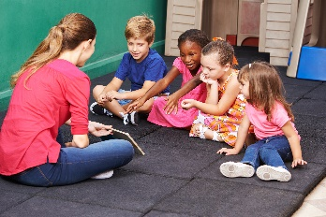
Preschool Programs
Our preschool classroom are focused on school readiness. They focus on enhancing your child’s confidence and independence by providing activities to help them become problem solvers and lifelong learners. Social skills are developed and nurtured as your preschooler is learning how to be a good friend. Classroom jobs introduce the concepts of responsibility and dependability to your child. (While we prefer children to be potty trained for pre-school, we will help your child continue to master this skill if needed.)
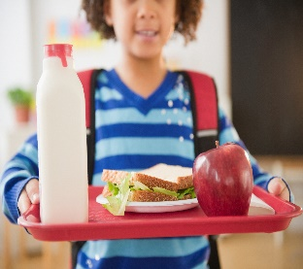 Free Meals & Snacks
Breakfast, lunch, and snack are provided to all enrolled children at no extra cost. So put those lunchboxes away!! No need to pack anything!! *We do not provide infant formula, infant food or snacks

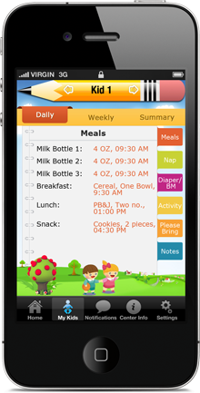
Our Parent Communication App
Our teachers communicate your child’s daily activities with you through our Procare app. Diapers, bottles, meals, naps and activities are all entered, as well as reminders for supplies and upcoming events!! Always know what happened in your child’s day!
(Infant through Preschool classes only)

Parent Testimonials
A great daycare!! Our daughter has been going since she was 10 weeks old, and she loves Kim and all the activities. We love the personal attention and activities like finger painting, coloring, made footprints, made cards for us, and outside play time. We would recommend for anyone who is looking for a great in-home daycare our daughter is turning 1 and loves getting us to go to daycare every weekday it is a great feeling to know that when we go off to work, she is happy being at daycare.
M.Theis

This is a great daycare. My daughter started here when she was 8 months old to the age of 3 years. We had her tested by P.A.T and we are proud to share that she is performing at upper 3 year and lower 4-year-old level. We want to take this opportunity to thank you from the bottom of our hearts for helping us establish her strong foundation. You are awesome and truly a God send to us.
Sara and Debbie C.

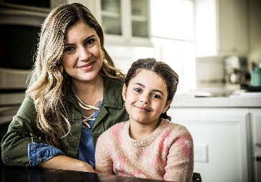
This is a Great daycare. My son started when he was 1 years old. He took an assessment test at preschool, and they are bumping him up to 4-5 year old Pre-Kindergarten class because he's so advance. We can't thank you enough for your skills and teaching efforts. T. Woods
RAVE!!! for over 2 years our little ones have been cared for by Kim Carson at Little Willows Daycare. She does a great job with helping them learn and grow. We feel confident that our kids are learning and growing in a safe nurturing environment. She has a free app that allows my wife and I to see their activities of the day from food and drinks consumed, to length of naps to much more! And she has encouraged us from day one to feel free to drop in anytime! We are blessed to have found her when we moved to Grandview. Cannot recommend her highly enough! (She cares for infants and children up to 5 years old) A.Trout
Our Rates
Infant 0-2years old $210
Young Toddler 2-3 years old $185
4-5 years old $175
* Tuition increases annually (August) to continue to operate a quality program and to keep up with the rising cost of the things in the economy.

